Resignation Letter

R. Murugan

No:187, T.Pazhur Road,

Jayankondam,

Ariyalur Dist-621802.

Mr. Siva Kumar

Associate Vice President - RMG

Crown Solution India Pvt Ltd

Chennai.

Dear Mr. Siva Kumar,

I would like to inform you that I am resigning from my position as Business Associate with Crown Solutions India Pvt Ltd., Last working day with Crown would be 31-Jul-2023.

Thank you for the opportunities you have provided me during my time with the company. If I can be of any assistance during this transition, please let me know.

Sincerely,

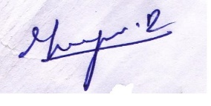

R. Murugan